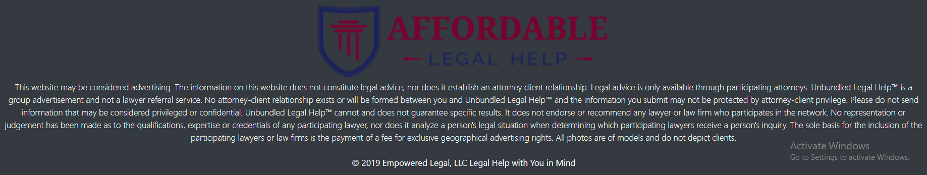

This website serves as an advertisement for Affordable Legal Help and the coalition of legal firms that fall under its umbrella. You may only gain legal advice from attorneys participating in Affordable Legal Help’s network. Affordable Legal Help is not a referral service for lawyers. Affordable Legal Help is a group advertisement that represents the efforts of dozens of experienced lawyers and attorneys. No contact or information that you share or give to Affordable Legal Help should be considered protected under the attorney-client privilege relationship. No attorney-client relationship exists or will be formed between you and Affordable Legal Help. Do not send sensitive or privileged information to Affordable Legal Help, as your information is not protected under any such relationship. Affordable Legal Help does not claim responsibility for any negative legal outcome you might experience or guarantee positive results. Affordable Legal Help does not make recommendations based on merit of attorneys, but rather their paid participation in our network that grants them advertising positioning on this website. All photos on this website are of paid models and do not represent real clients.